Bootstrap is long so personally he gonna delete the library

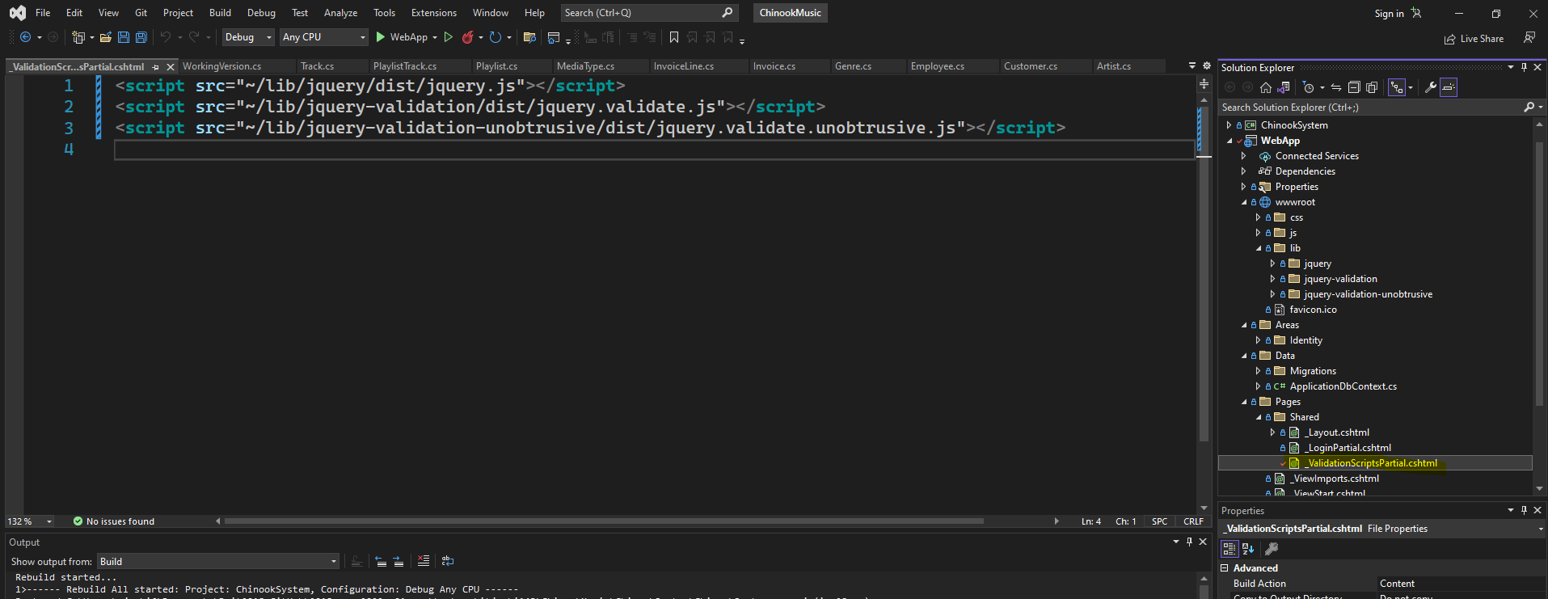

Modify the highlighted file